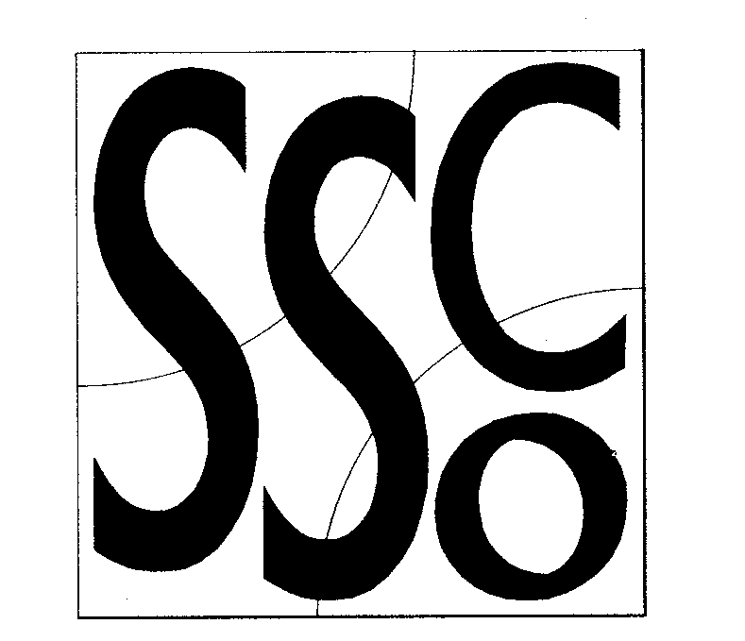

Teaching Points
‘Bowl’ like shape with hands to catch.
Keep emphasis on catching & not tricks.
Keep eyes on the object.
Underarm throwing

Throwing & Catching 2
MULTI SKILL CARDS



Classification
Throwing and catching
Hand eye co-ordination.

Equipment
Tennis balls, bean bags, quoits, large balls, small balls., reaction balls.

Differentiation
Harder: Use smaller objects Encourage harder tricks..

Easier: Use larger objects

Activity/ Key Points

- Pupil 1 and 2 stand opposite each other throwing with 1 hand and catching with 2 (pic1)

- Introduce a clap before catching..

- Introduce 2 tennis balls. Each person has one each on the command they both throw the ball to each other.

- Pupil 1 faces away from pupil 2, pupil 2 shouts ‘Go’, pupil 1 reacts to the command and catches the ball.

- Repeat the above 2 drills but bounce the ball to the partner. Introduce a reaction ball to make it harder.

- Pupil 1 holds 2 tennis balls as in pic 1.Pupil 1 then releases one of the tennis balls with pupil 2 reacting to the ball as quick as possible.

Pic 1
Pic 2.

